Product Requirements Document: Autonomous PM Governance Platform

1. Product Overview
An AI-driven project management platform that generates, validates, and governs project artifacts (charter, WBS, plan) across the full project lifecycle (Initiation → Planning → Execution → Operations → Closure), with autonomous AI agents proposing actions and humans retaining approval authority over anything consequential.
The product is not a passive document generator — it actively monitors project health, flags risk, and proposes interventions, while keeping a full audit trail of every AI action and every human decision.
2. User Personas
2.1 Project Manager — primary daily user
Role: Owns day-to-day delivery of one or more projects. Goals: Move projects through phase gates efficiently, keep documents audit-ready, resolve flagged risks before they become real problems. Pain points today: Manually drafting charters/WBS is slow; risks are often noticed too late; tracking deliverable status across tools is tedious. What she needs from this product: A single dashboard showing phase progress, deliverable status, and pending items needing her decision — not just AI-generated documents to proofread from scratch.
2.2 Executive — infrequent, high-level user
Role: Portfolio-level oversight; cares about outcomes, not mechanics. Goals: Understand project health at a glance; only get pulled in when something needs executive-level authority (budget, cross-team escalation). Pain points today: Status reports are stale by the time he sees them; he's often the last to know about a risk that needed his input weeks ago. What he needs from this product: An executive summary view, and proactive escalation only for the subset of decisions that genuinely need his authority — not a firehose of every AI action.
2.3 Sponsor — budget & approval authority
Role: Owns the business case and budget for the project; approves scope and budget changes. Goals: Confidence that the project remains within approved scope, budget, and risk tolerance; wants to see ROI/value tracking, not just task completion. Pain points today: Scope creep and budget risk are often invisible until a formal review; approvals happen too late to prevent drift. What she needs from this product: Visibility into anything touching budget or scope the moment it's flagged, with a clear approve/reject action tied directly to her authority — not a document to interpret.
2.4 Auditor — compliance & governance reviewer
Role: Reviews projects (often after the fact) for governance and compliance adherence; does not take operational actions. Goals: Reconstruct exactly what happened, when, by whom (human or AI), and why — quickly, without needing to interview the project team. Pain points today: Audit trails are scattered across email, chat, and documents; reconstructing a decision's rationale after the fact is slow. What he needs from this product: A complete, read-only, chronological record of every AI proposal, every human decision, and every document revision — exportable for formal review.
3. User Stories
Organized by epic. Each story is tagged with the persona(s) it serves.
Epic: Charter & WBS Generation (Initiation/Planning)
- US-01 (PM): As a PM, I want to submit a project brief and receive a draft charter grounded in real org/budget data, so I don't start from a blank page or invent stakeholder names.
- US-02 (PM): As a PM, I want the charter automatically checked for structural completeness before I see it, so I don't waste review time on missing sections.
- US-03 (PM): As a PM, I want the WBS checked against the charter for consistency, so scope gaps are caught before planning is finalized.
- US-04 (Sponsor): As a sponsor, I want to see the approved charter's budget and scope clearly, so I can confirm it matches what I authorized.
Epic: Phase Gates & Deliverable Tracking
- US-05 (PM): As a PM, I want to see all deliverables for the current phase with their status, so I know what's blocking progression.
- US-06 (PM): As a PM, I want a phase to be visibly locked until its gating deliverables are complete, so I don't accidentally start work that depends on unfinished prerequisites.
- US-07 (Executive): As an executive, I want a single project-health score and phase-progress summary, so I can assess status in seconds without reading every deliverable.
Epic: Risk Detection & Escalation
- US-08 (PM): As a PM, I want the system to flag deliverables at risk of missing their deadline, so I can act before the deadline passes, not after.
- US-09 (PM/Executive): As a PM or executive, I want the system to propose a specific action for a detected risk (e.g. escalate, reassign), not just flag a problem with no next step.
- US-10 (Executive/Sponsor): As an executive or sponsor, I want to approve or reject a proposed escalation directly from the dashboard, so I don't have to leave the tool to act on it.
Epic: Approval Workflow
- US-11 (Sponsor): As a sponsor, I want any AI-proposed action that touches budget or scope routed to me specifically for approval, so nothing consequential happens without my sign-off.
- US-12 (PM): As a PM, I want to see the status of everything pending approval, so I know what's blocked on someone else's decision versus blocked on my own work.
Epic: Role-Based Views
- US-13 (all personas): As a user, I want to switch between role-based views of the same project, so I see the information relevant to my responsibility without the platform requiring separate logins/tools.
- US-14 (Auditor): As an auditor, I want a read-only view with no action buttons, so I can review without any risk of accidentally altering project state.
Epic: Audit & Compliance
- US-15 (Auditor): As an auditor, I want a chronological log of every AI action and every human decision, with timestamps and actors, so I can reconstruct what happened without interviewing the team.
- US-16 (Auditor): As an auditor, I want to export the audit trail for a given project, so I can include it in a formal compliance review.
4. Functional Requirements
Grouped by module, cross-referenced to DESIGN.md sections.
4.1 Charter & Planning Agents (DESIGN.md §5)
- FR-01: System shall generate a draft charter from a project brief, grounded in org chart and budget data retrieved for the relevant scope.
- FR-02: System shall not allow the charter agent to output stakeholder names, roles, or budget figures not present in the supplied grounding data.
- FR-03: System shall generate a WBS from an approved charter only — the planning agent shall not run against an unapproved charter.
4.2 Structural & Consistency Critics (DESIGN.md §6)
- FR-04: System shall validate every charter against a fixed structural rubric before it can proceed to planning.
- FR-05: System shall validate every WBS against completeness and the 100%-rule before it can proceed to consistency checking.
- FR-06: System shall check charter/WBS consistency and block phase progression until both pass.
- FR-07: Every critic rejection shall include the specific component or item flagged and a concrete suggestion — not a generic failure message.
4.3 Revision & Cost Control (DESIGN.md §7–8)
- FR-08: System shall cap revision attempts per document at a configurable limit (default 3), enforced in code, not by prompt instruction.
- FR-09: System shall enforce a per-project-run cost ceiling and halt with a flag for human review if exceeded.
- FR-10: System shall log token usage and cache hit/miss per agent call for cost auditing.
4.4 Phase-Gate Engine
- FR-11: System shall define, per phase, which deliverables are gating (block progression) versus advisory (informational only).
- FR-12: System shall prevent a phase's work from starting until all gating deliverables of the prior phase are marked complete.
- FR-13: System shall display phase progress as a fraction (e.g. "2/4 deliverables complete") and a percentage, visible to all personas.
4.5 Risk Detection Agent
- FR-14: System shall monitor deliverable due dates and status, and flag items at risk of deadline breach.
- FR-15: System shall classify each detected risk by severity (high/medium/low) using defined criteria (e.g. days-until-due vs. percent complete).
- FR-16: System shall propose a specific, actionable next step for each detected risk — not a bare notification.
4.6 Approval Workflow Engine
- FR-17: System shall route any AI-proposed action with budget, scope, or cross-team impact to a pending-approval state before execution.
- FR-18: System shall never execute a proposed action automatically — execution requires an explicit human approve action.
- FR-19: System shall log the outcome (approved/rejected), the acting human, and the timestamp for every proposed action.
- FR-20: System shall notify the correct persona (e.g. sponsor for budget items, executive for cross-team escalations) based on the proposed action's type.
4.7 Role-Based Dashboard
- FR-21: System shall provide distinct views for PM, Executive, Sponsor, and Auditor personas from the same underlying project data.
- FR-22: Auditor view shall be strictly read-only — no approve, reject, or edit actions available.
- FR-23: Executive view shall default to a summary (health score, phase progress, active risk count, pending approvals) rather than full deliverable-level detail.
4.8 Audit & Compliance
- FR-24: System shall log every document revision, every critique, every AI-proposed action, and every human decision in a single chronological, queryable audit trail per project.
- FR-25: System shall support exporting the full audit trail for a given project in a human-readable format.
- FR-26: Audit log entries shall be immutable once written.
5. Non-Functional Requirements
- NFR-01 (Auditability): Every state-changing action must be attributable to a specific actor (agent name + version, or human user ID).
- NFR-02 (Predictability): No agent may take an irreversible action without passing through the Approval Workflow Engine, regardless of confidence score.
- NFR-03 (Cost bounding): No single project run may exceed the configured cost ceiling without triggering a human-visible halt.
- NFR-04 (Latency): Dashboard views should load from cached/precomputed state where possible; live agent calls should not block page render.
- NFR-05 (Data grounding accuracy): Any agent output referencing organizational entities (people, budgets) must be traceable to a specific source-system record, not model-generated content.
6. Traceability at a Glance
Persona | Key stories | Key requirements
Project Manager | US-01–03, 05–06, 08–09, 12 | FR-01–10, FR-14–16
Executive | US-07, 09–10 | FR-13, FR-20, FR-23
Sponsor | US-04, 10–11 | FR-17–20
Auditor | US-14–16 | FR-22, FR-24–26
7. Open Questions (product-level, distinct from DESIGN.md §11)
- What counts as "budget or scope impact" precisely, for FR-17's routing logic? Needs a concrete threshold/definition before it can be built.
- Should Executives be able to delegate approval authority, or must every routed item go to a named individual?
- Does the Auditor role need real-time access, or is a periodic (e.g. weekly) export sufficient for the compliance use case?

Product Snapshots:
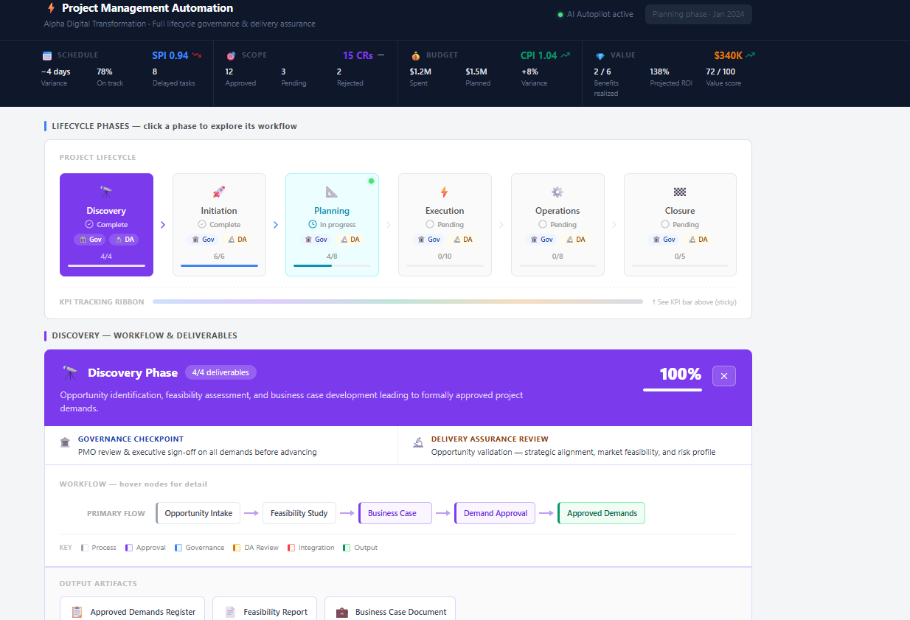

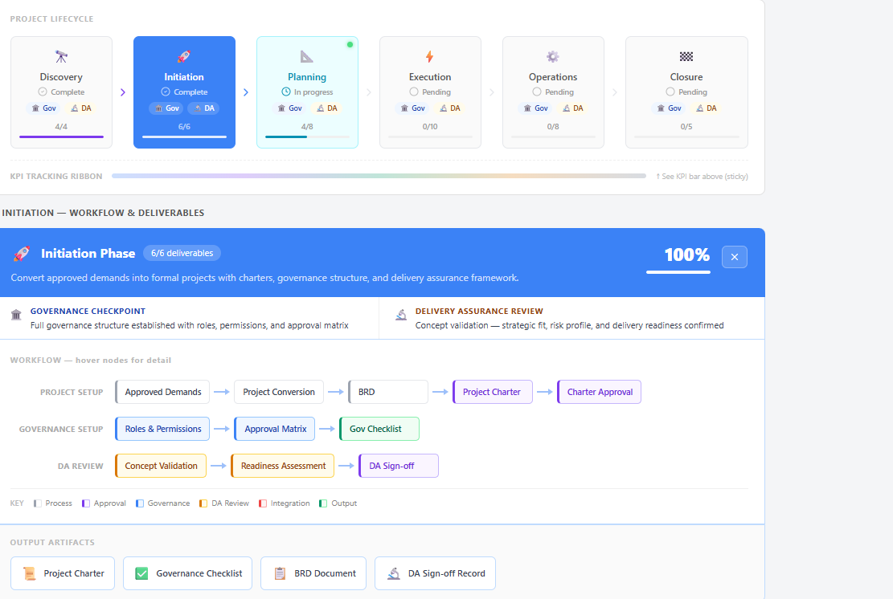
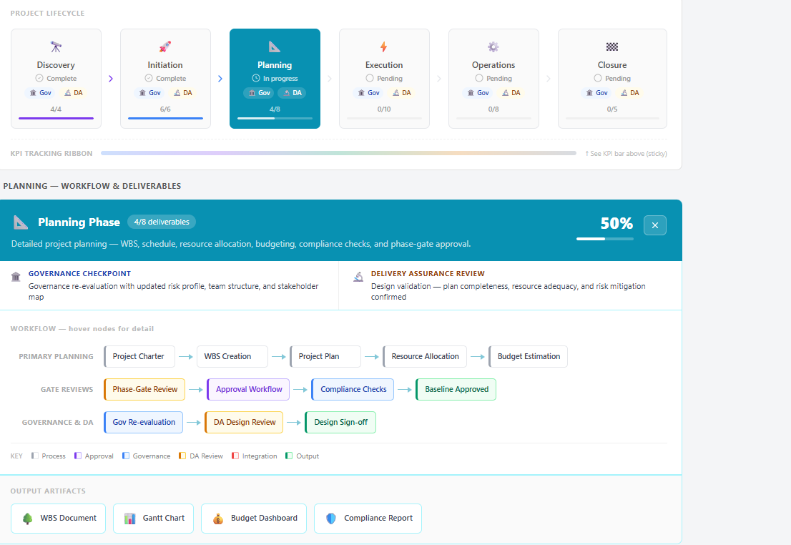

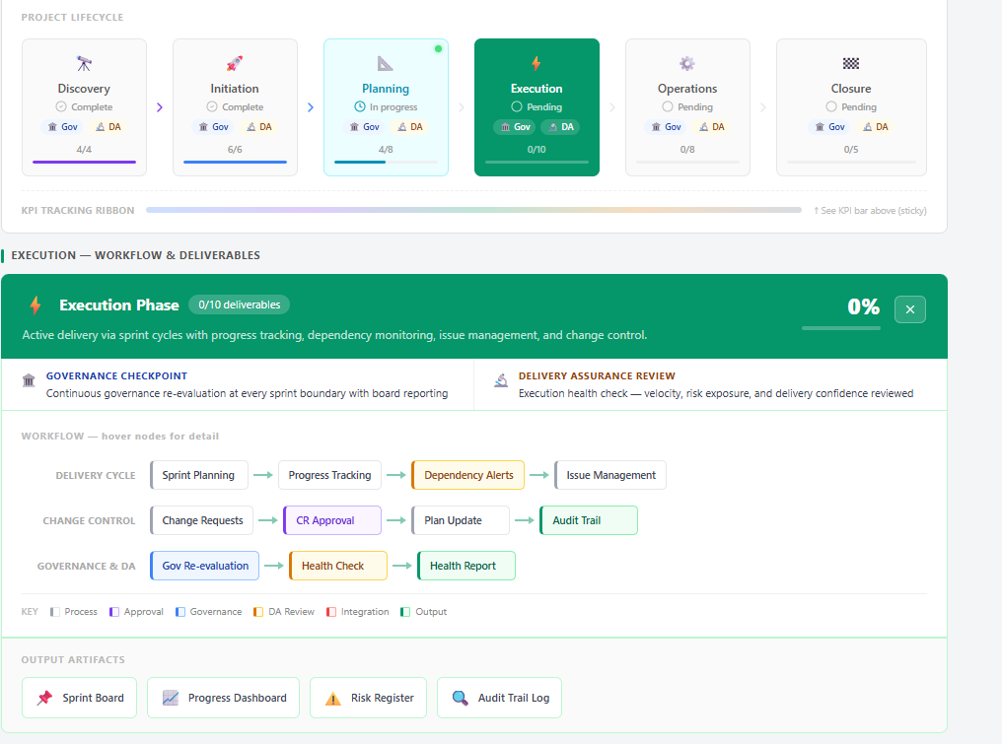
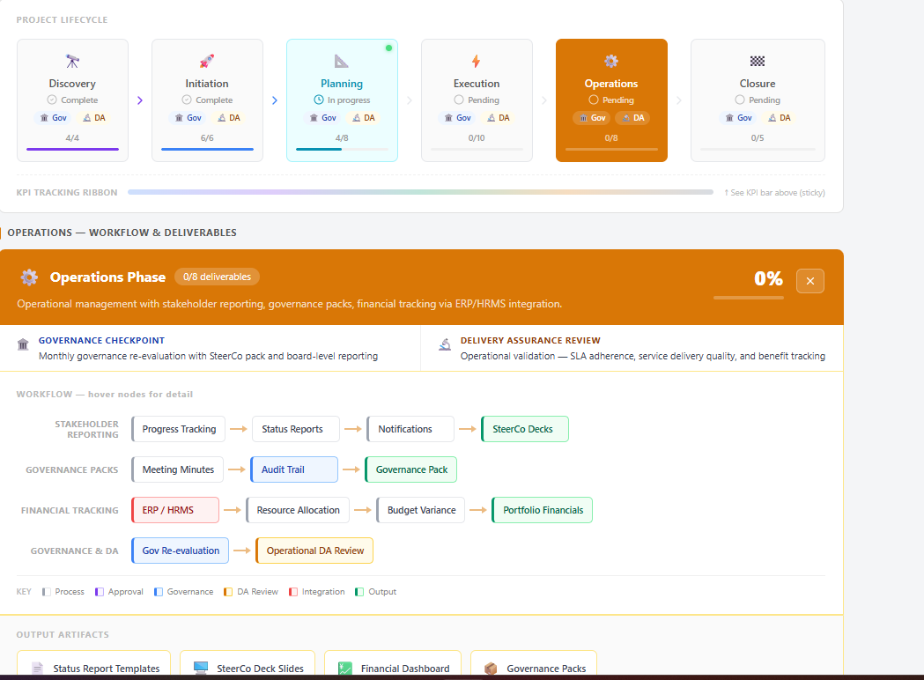
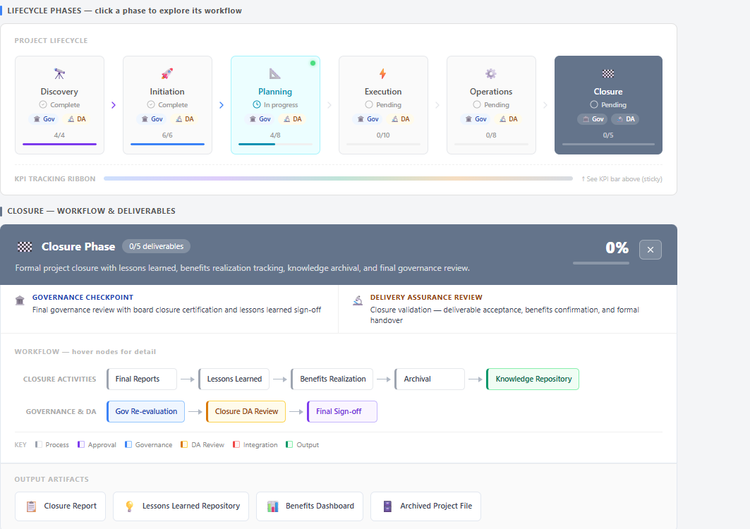

Charter input :
INPUT FORMATS (12+ types):
Documents: Word, PDF, Excel, PPT, Text, Google Docs, Confluence
Diagrams: Use case, Flow chart, Architecture, Wireframes, Screenshots
Media: Video, Audio, Transcription
Code: Jira issues, GitHub, Code repos, Slack
Data: JSON, YAML, CSV, Database export
OUTPUT FORMATS (10+ types):
Documents: Word (.docx), PDF, Markdown, Google Doc
Presentations: PowerPoint, Keynote, Google Slides, PDF slides
Visuals: Infographic, Mind map, Swimlane diagram
Interactive: HTML dashboard, Notion, Confluence
Data: JSON, CSV, Excel

